**Exercise 1: Hello friends**

Write the program and compile the code @command line to execute to greet your friends.

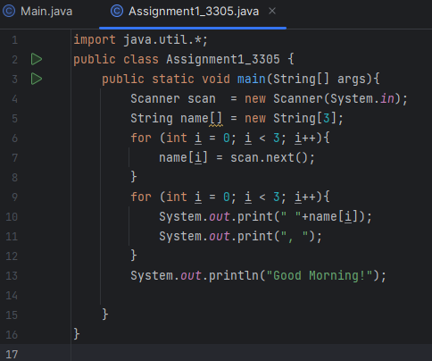

**OUTPUT**

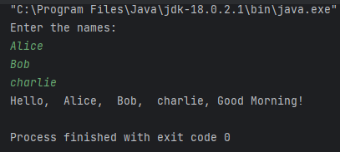

**Exercise 2: Error message**

Find the maximum Compile time and Run time error messages of simple one line output message.

1. Delete any one of the semicolons

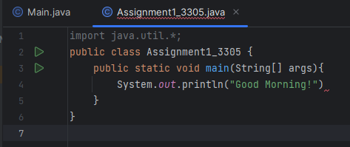

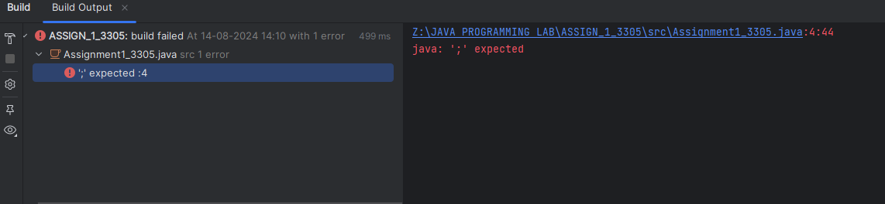

1. Swap the word public, static, void, main

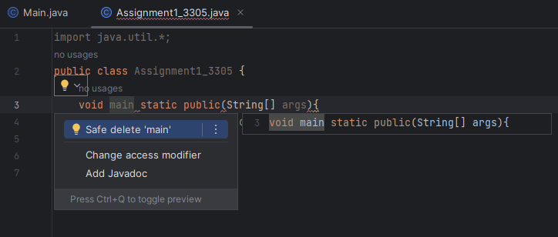

1. Omit the word public, static, void, main

* void missed

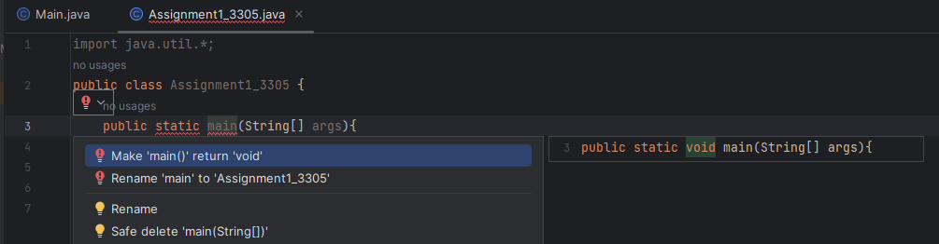

* public missed

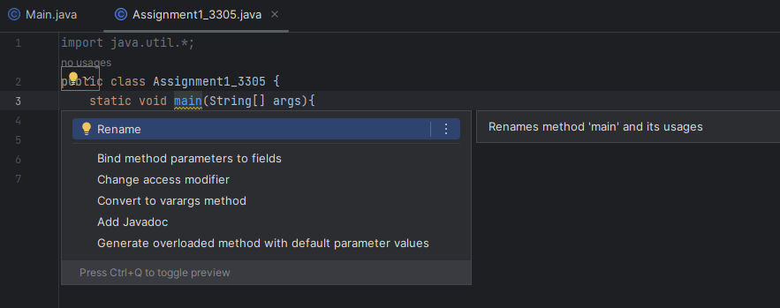

* main missed

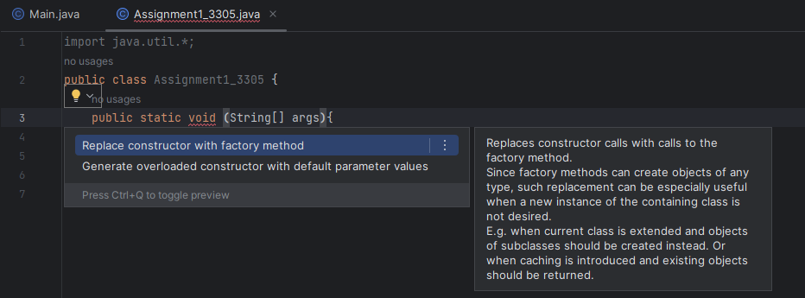

* static missed

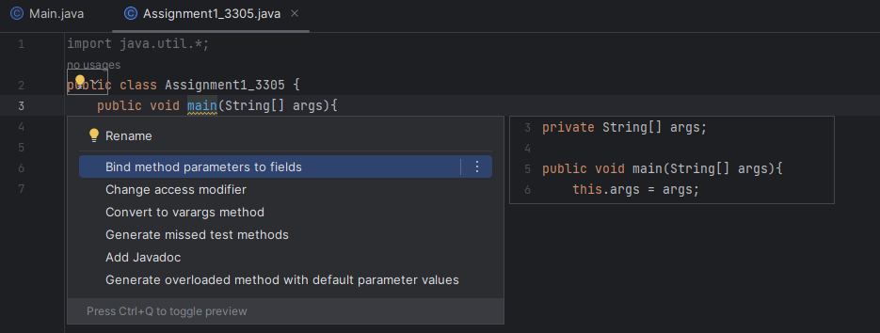\

1. Remove the array subscript arround the string

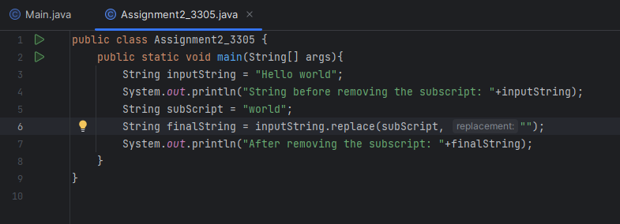

**OUTPUT**

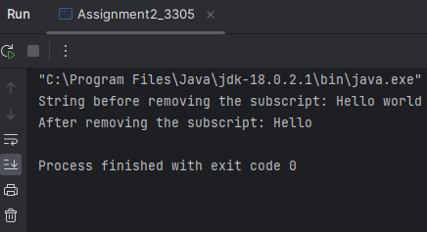

1. Replace String with int or float

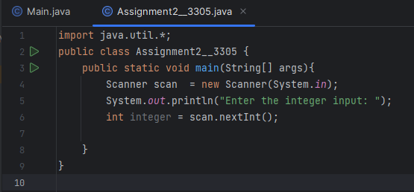

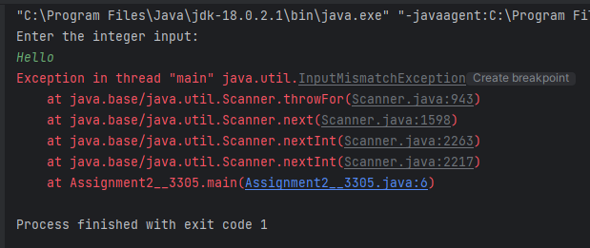

1. Replace String[] as String...

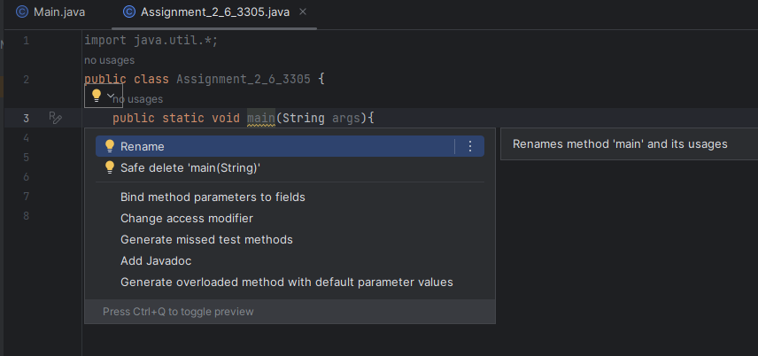

**Exercise 3: Conversation**

Write a Java program to create a Conversation between Java and Python

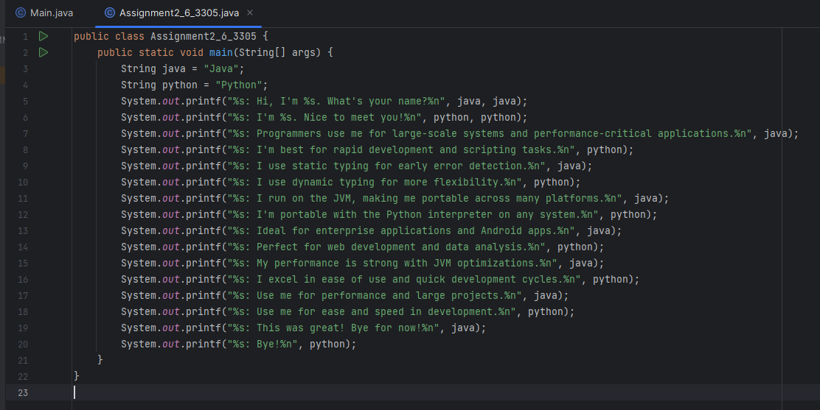

**OUTPUT**

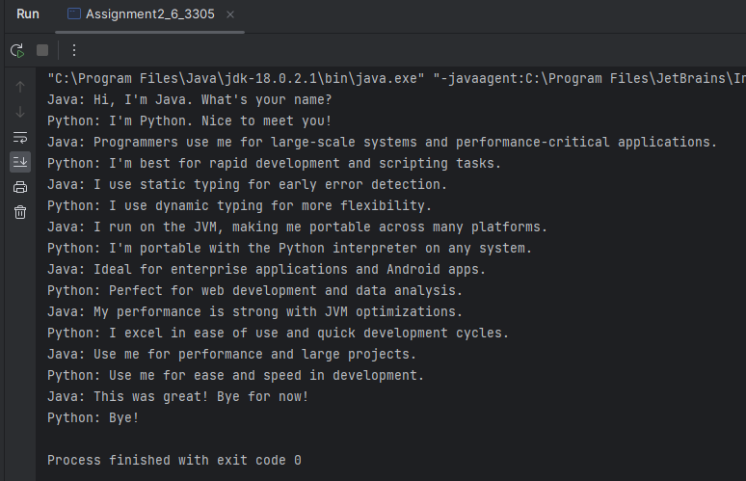

**Exercise 4: Leap year**

Write a program to check if the given year is a leap year or not.

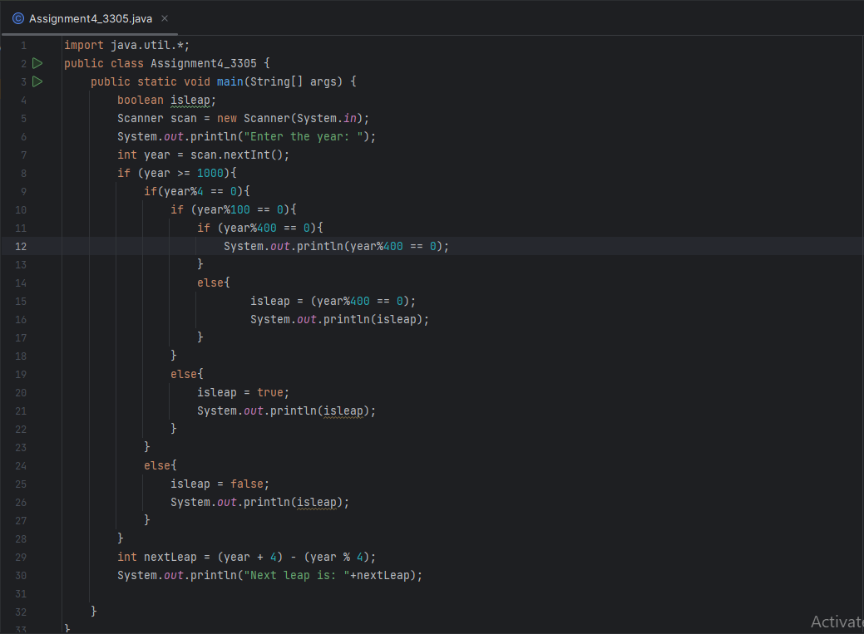

**OUTPUT**

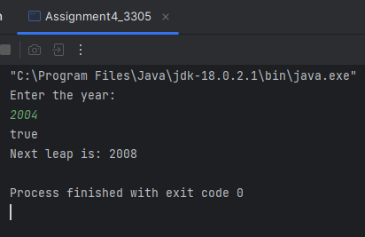

**Exercise 5: Day of the Week**

Write a program that takes a date as input and prints the day of the week that date falls on. Read the three int input as m(month), d(day) and y(year). Use 1 of m for January, 2 for February, and so forth. For output print 0 for Sunday, 1 for Monday and so forth. Use the following formula for the Gregorian calendar.

import java.util.Scanner;  
class Assignment1_5_3305  
{  
 public static void main(String[] args)  
 {  
 int date ,month,year;  
 System.*out*.println("Date: ");  
 Scanner sc = new Scanner(System.*in*);  
 date=sc.nextInt();  
 System.*out*.println("Month(in numbers): ");  
 month=sc.nextInt();  
 System.*out*.println("Year: ");  
 year=sc.nextInt();  
 int x, y , m , d;  
 y = year - 1;  
 x = y + y / 4 - y / 100 + y / 400;  
 m = month + 12 * 1 - month;  
 d = (date + x + (31 * m) / 12) %7 ;  
 if ( d == 0)  
  
 {  
 System.*out*.println("Sunday");  
 }  
else if (d == 1)  
 {  
 System.*out*.println("Monday");  
 }  
 else if (d == 2)  
 {  
 System.*out*.println("Tuesday");  
 }  
 else if (d == 3)  
 {  
 System.*out*.println("Wednesday");  
 }  
 else if (d == 4)  
 {  
 System.*out*.println("Thursday");  
 }  
 else if (d == 5)  
 {  
 System.*out*.println("Friday");  
 }  
 else  
 {  
 System.*out*.println("Saturday");  
 }  
  
 }  
}

**OUTPUT**

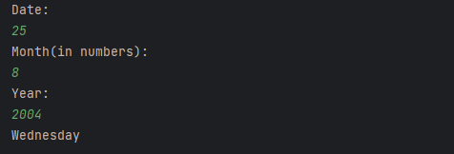

**Exercise 6:**

**Write a Java program to create a Indian Flag**  
public class Assignment1_6_3305 {  
 // main() method start   
 public static void main(String[] args) {  
  
 // declare and initialize variables   
 int height = 26;  
 int width = 40;  
 int temp = 3;  
  
 // we use only one nested loop to print all the parts of the flag   
 for(int m = 1; m<= height; m++) {  
 for(int n = 1; n <= width; n++){  
  
 // create first layer of Indian flag   
 if(m <= 4) {  
 if(m == 1 || m == 4) {  
 if(n >= 15 && n<= 35) {  
 System.*out*.print("-");  
 } else {  
 System.*out*.print(" ");  
 }  
 } else {  
 if(m ==2 || m ==3) {  
 if(n == 15 || n == 35) {  
 System.*out*.print("|");  
 } else {  
 System.*out*.print(" ");  
 }  
 }  
 }  
 }  
 if(m > 4 && m <= 8) {  
 // second layer of the flag   
 if(m <= 7) {  
 if(n == 15 || n == 35) {  
 System.*out*.print("|");  
 } else {  
 if(n >= 22 && n<= 28) {  
 System.*out*.print("*");  
 } else {  
 System.*out*.print(" ");  
 }  
 }  
 } else {  
 if(n >= 15 && n<= 35) {  
 System.*out*.print("-");  
 } else {  
 System.*out*.print(" ");  
 }  
 }  
 }  
 if(m > 8 && m <= 11) {  
 // third layer of the flag   
 if(m <= 10) {  
 if(n == 15 || n == 35) {  
 System.*out*.print("|");  
 } else {  
 System.*out*.print(" ");  
 }  
 } else {  
 if(n >= 15 && n <= 35) {  
 System.*out*.print("-");  
 } else {  
 System.*out*.print(" ");  
 }  
 }  
 }  
 if( m >= 12 && m <= 19) {  
 // stick of the flag   
 if(n == 15) {  
 System.*out*.print("|");  
 } else {  
 System.*out*.print(" ");  
 }  
 }  
 // stairs of the flag   
 if( m >= 20) {  
 if(m % 2 == 0) {  
 if(n >= 15 - temp && n <= 15 + temp) {  
 System.*out*.print("-");  
 } else {  
 System.*out*.print(" ");  
 }  
 } else {  
 if(n == 15 - temp || n == 15 + temp) {  
 System.*out*.print("|");  
 } else {  
 System.*out*.print(" ");  
 }  
 }  
 }  
 }  
 if(m >= 20) {  
 if(m % 2 != 0) {  
 temp++;  
 }  
 }  
 System.*out*.print("\n");  
 }  
 }  
}

**OUTPUT**

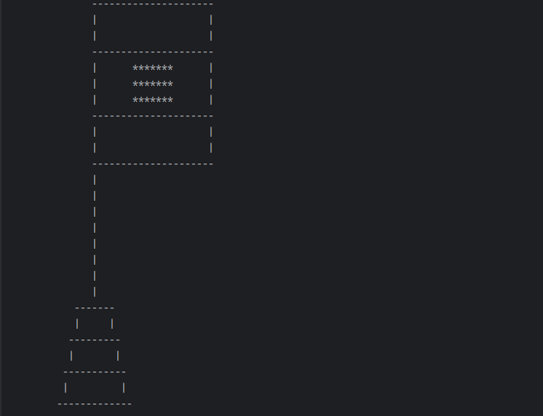

**Exercise 7: Model OR gate**

import java.util.Scanner;  
class Assignment1_7_3305 {  
 public static int andgate(int x1 , int x2)  
 {  
 double w0 = 1.0;  
 double w1 = 1.0;  
 double bias = 1.0;  
 double y = bias + w0 * x1 + w1 * x2;  
 if (y > 0.5)  
 {  
 return 1;  
 }  
 else  
 {  
 return 0;  
 }  
 }  
 public static void main(String[] args)  
 {  
 System.*out*.println(*andgate*(0,0));  
 System.*out*.println(*andgate*(0,1));  
 System.*out*.println(*andgate*(1,0));  
 System.*out*.println(*andgate*(1,1));  
 }  
}

**OUTPUT**

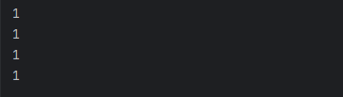

**Exercise 8:**

**Write a program that converts a given integer into its equivalent words representation. The program should handle negative numbers and checks if the input is within the specified range of 0 to 999.**

import java.util.Scanner;  
public class Assignment1_8_3305 {  
 private static final String[] *units* = {"", "One", "Two", "Three", "Four", "Five", "Six", "Seven",  
 "Eight", "Nine", "Ten",  
 "Eleven", "Twelve", "Thirteen", "Fourteen", "Fifteen", "Sixteen", "Seventeen", "Eighteen",  
 "Nineteen"};  
 private static final String[] *tens* = {"", "", "Twenty", "Thirty", "Forty", "Fifty", "Sixty", "Seventy",  
 "Eighty", "Ninety"};  
 public static String convertToWords(int number) {  
 if (number == 0)

return "Zero";  
 if (number < 0)

return "Negative " + *convertToWords*(-number);  
 if (number < 20)

return *units*[number];  
 if (number < 100)

return *tens*[number / 10] + (number % 10 == 0 ? "" : " " + *units*[number %  
 10]);  
 return *units*[number / 100] + " Hundred" + (number % 100 == 0 ? "" : " and " +  
 *convertToWords*(number % 100));  
 }  
 public static void main(String[] args) {  
 System.*out*.println("Enter the number to search:");  
 Scanner sc = new Scanner(System.*in*);  
 int n=sc.nextInt();  
 System.*out*.println(*convertToWords*(n));  
 }  
}

**OUTPUT**

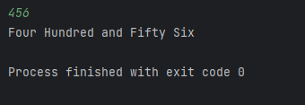

**Exercise 9: Casino Game**

import java.util.Random;

import java.util.Scanner;

public class CasinoGame3301 {

public static void main(String[] args) {

Scanner scanner = new Scanner(System.in);

Random random = new Random();

int credits = 1000;

int betAmount = 100;

int targetCredits = 2000;

System.out.println("Welcome to the Casino! You start with 1000 credits.");

while (credits > 0 && credits < targetCredits) {

System.out.println("Press 'r' to roll the dice (100 credits per roll): ");

String input = scanner.nextLine();

if (input.equalsIgnoreCase("r")) {

credits -= betAmount;

int dice1 = random.nextInt(6) + 1;

int dice2 = random.nextInt(6) + 1;

int sum = dice1 + dice2;

System.out.println("You rolled: " + dice1 + " + " + dice2 + " = " + sum);

if (sum == 7 || sum == 11) {

credits += 200;

System.out.println("You win! Current credits: " + credits);

} else if (sum == 2 || sum == 3 || sum == 12)

{

System.out.println("You lose! Current credits: " + credits);

} else

{

System.out.println("No change in credits. Current credits: " + credits);

}

} else {

System.out.println("Invalid input. Please press 'r' to roll the dice.");

}

}

if (credits <= 0) {

System.out.println("You're bankrupt! Game over.");

} else {

System.out.println("Congratulations! You reached 2000 credits. You win!");

}

scanner.close();

}

}

**OUTPUT**

